BROCK O’CONNOR MEMORIAL SCHOLARSHIP
Application Form
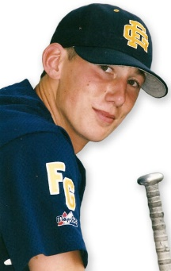
This scholarship was established in July of 2000 and has continued to grow through the loving support of people, much like Brock, that believe that all young people should have the opportunity to participate in the “all-American pastime,” baseball. It is truly an honor to be associated with this scholarship & to share in Brock’s love of baseball & his desires to help others. May this fund be a blessing to you & your family.
Sincerely,
Brock O’Connor Memorial Scholarship Fund Committee.

GENERAL INFORMATION Today’s Date: _________________

Contact Name: ______________________________ Relationship to player: __________________
(Parents/Guardian/Coach/Teacher) (Mother/Father/Coach, etc.)
Address: ________________________________________________________________________
(Address, City, State, Zip)
Phone: __________________________ Email: __________________________________________
Circumstances for request: __________________________________________________________
________________________________________________________________________________
Has the player (or players) below ever been a recipient of the Brock O’Connor Scholarship fund? If so, what year? ____________________________________________
How did you hear about this fund? _____________________________________________________
Additional comments:

PLAYER INFORMATION
Name: _________________________________________________________________
Birthday: _____________________ League age: __________________
League: _______________________________________________
Registration Fee request: Yes No
Equipment &/or uniform request: Yes No
If you are requesting equipment &/or uniform, pleases check the items below:
Bat | Belt | Cleats | Cup | Mitt | Pant | Socks | T-Shirt (LS)

Other request: ______________________________________________________________

Name: _________________________________________________________________
Birthday: _____________________ League age: __________________
League: _______________________________________________
Registration Fee request: Yes No
Equipment &/or uniform request: Yes No

If you are requesting equipment &/or uniform, pleases check the items below:
Bat | Belt | Cleats | Cup | Mitt | Pant | Socks | T-Shirt (LS)

Other request: ______________________________________________________________

Email this form to: Jim@Ardissono.com
or call Jim Ardissono at 425-391-5567

